Experiment: 10
5G Network Slicing Environment Using MATLAB
Ch.Vishnu Vardhan
192412150

OBJECTIVE:1:
Analyze the creation and allocation of multiple network slices in a 5G network using MATLAB. Observe how different slices can be configured to support diverse service requirements and applications.

MATLAB CODE:
clc;
clear;
close all;
slices = {'eMBB','URLLC','mMTC','Private','IoT'};
count = [1 1 1 1 1];
figure
bar(count)
% One instance of each network slice
grid on
set(gca,'XTickLabel',slices)
xlabel('Network Slice Type')
ylabel('Number of Network Slices')
title('Number of Configured 5G Network Slices')

OUTPUT:

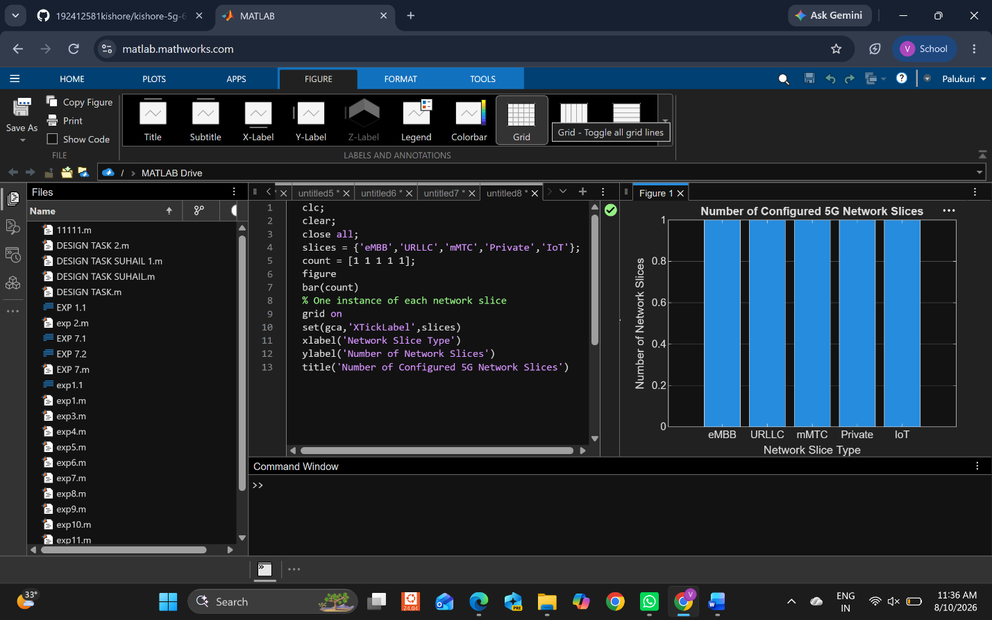

OBJECTIVE:2:
Compare the utilization of different network slices using MATLAB. Analyze how efficiently network resources are allocated and utilized across multiple slices.

MATLAB CODE:
clc;
clear;
close all;
slices = categorical({'eMBB','URLLC','mMTC','Private','IoT'});
utilization = [85 70 60 75 50];
figure;
bar(slices, utilization);
grid on;
xlabel('Network Slice Type');
ylabel('Slice Utilization (%)');
title('Slice Utilization in 5G Network Slicing');
ylim([0 100]);

OUTPUT:

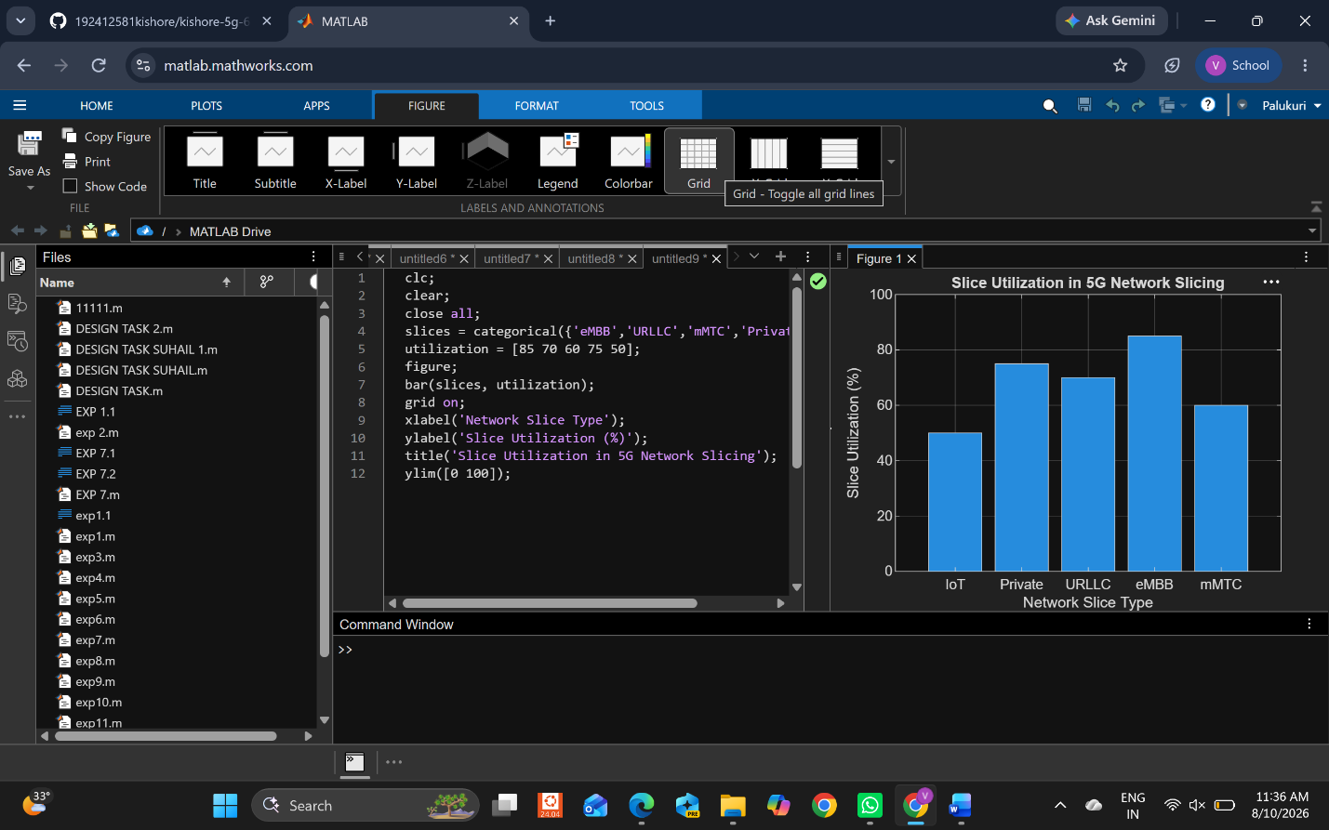

OBJECTIVE:3:
Analyze the end-to-end latency of different network slices using MATLAB. Compare the latency values to understand the Quality of Service (QoS) requirements of various 5G applications.

MATLAB CODE:

clc;
clear;
close all;
slices = [1 2 3 4 5];
latency = [25 5 40 15 60];
figure;
plot(slices, latency, '-o','LineWidth',2,'MarkerSize',8);
grid on;
xticks(slices);
xticklabels({'eMBB','URLLC','mMTC','Private','IoT'});
xlabel('Network Slice Type');
ylabel('End-to-End Latency (ms)');
title('5G Network Slicing: End-to-End Latency');

OUTPUT:

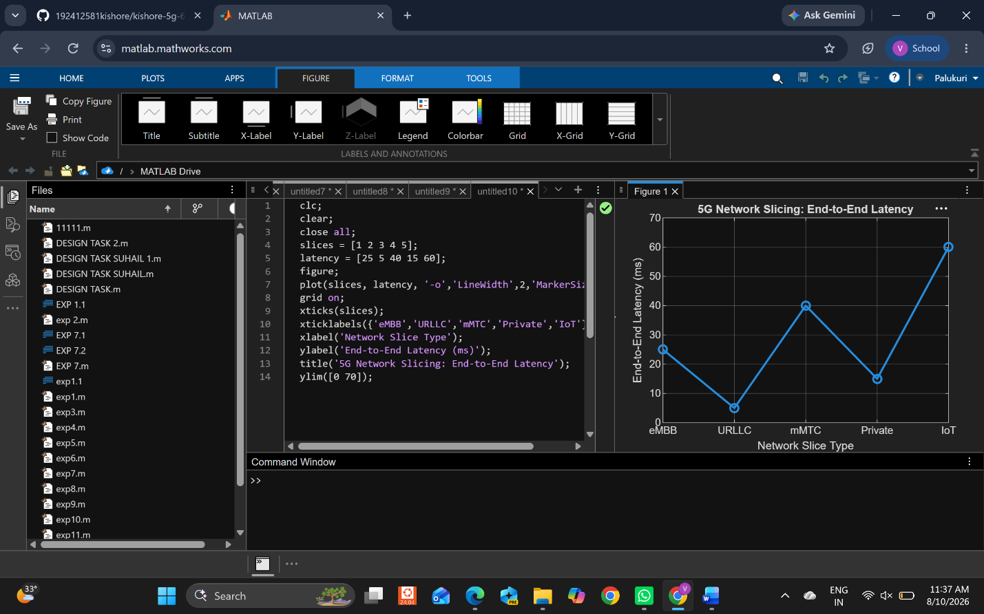

Result :
The MATLAB analysis successfully demonstrated the characteristics of a 5G Network
Slicing environment. The results showed that multiple network slices can coexist while
exhibiting different utilization levels and latency characteristics based on their intended
services.

